

|  |
| --- |
|  |
|  |
| **Instructors Name:** Dr. Silvester Namuye  **Course Description:** Introduction to Digital Electronics  **Course number:** APT2030A  **Semester:** Fall semester  **Experiment:** Laser Trip-wire using Raspberry pi  **Date Done:** 26/11/2017  **GROUP 2 MEMBERS** |

1. Dickson John Finney 646509
2. Catherine Wairimu Ngugi 649846
3. Sylvia Macharia 650694

# ABSTRACT

The project was a small-scale implementation of a laser detection system often used to safeguard systems and alert management about possible intruders. The main objective of the project was to create a laser detection system using available resources. Tools used to realize the experiment included: a raspberry pi, a breadboard, a 10 μF capacitor, a light-dependent resistor(LDR), a light-emitting diode(LDR), a single throw switch, jumper leads and a laser pointer. By connecting the listed components, the team was able to successfully build the system. The system buzzer went off and LED lights flashed when laser pointed on light sensor was interrupted. When laser was uninterrupted, the system buzzer was quiet and LED lights off. In conclusion, students learned how to implement an example of a modern-day sensor system by using an LDR to measure light levels and controlling a buzzer.

Table of Contents

ABSTRACT 2

INTRODUCTION 4

OBJECTIVES 4

APPARATUS 5

Hardware 5

Software 5

PROCEDURE 5

OBSERVATION AND RESULTS 9

DISCUSSION OF RESULTS 9

CONCLUSION 10

REFERENCES 11

Table of Figures

Figure 1: Shielding the LDR 6

Figure 2: Circuit configuration 7

Figure 3 Circuit Diagram 7

Figure 4: LASER focused at the LDR 9

Figure 5: LASER intercepted 9

# INTRODUCTION

The project was designed to help students learn about and understand an instance of a sensor system. The laser tripwire project used a laser to act like a virtual tripwire which set off a sound system when intercepted. In addition to this reaction, the LED light would also light up. Components used to build the system include: a raspberry pi, a breadboard, a 10 μF capacitor, a light-dependent resistor(LDR), a light-emitting diode(LDR), a single throw switch, jumper leads and a laser pointer. By use of above resources, the system was connected. A python script was run on the raspberry pi to act as interface between the several sections of the system. In addition to this, a single throw switch was used to act as a manual switch for system. In essence the system consisted of three main sections: one receiving input from the environment, the other interpreting this result and the last giving out output from system. Main components in each section include: LDR for the input, python script running on raspberry pi for interpretation and the buzzer and LED light in the output section.

# OBJECTIVES

1. Create a sensor system.
2. Identify components used in a laser detection system.
3. To understand general structure of a laser detection sensor system.
4. Be able to use raspberry pi to implement a system.
5. Measure light levels with LDR.
6. To implement a laser detection system.

# APPARATUS

Below is a list of all the apparatus that was used to perform the project.

### Hardware

* Raspberry pi
* A breadboard
* A 10μF capacitor
* A light-dependent resistor (LDR)
* Jumper leads
* A LASER pointer
* Piezo Buzzer
* Light Emitting Diode (LED)
* Single-throw switch

### Software

All required software is pre-installed on Raspbian.

# PROCEDURE

The first step is to assemble the components on a breadboard and create a simple prototype to detect whether or not a beam of light is hitting the **l**ight-**d**ependent **r**esistor (LDR).

It’s a good idea to shield the LDR to make sure that only light from the laser pointer will trigger the program. It can be done with a section of a drinking straw or even more easily with a small roll of paper stuck together with glue like shown in Figure 1.

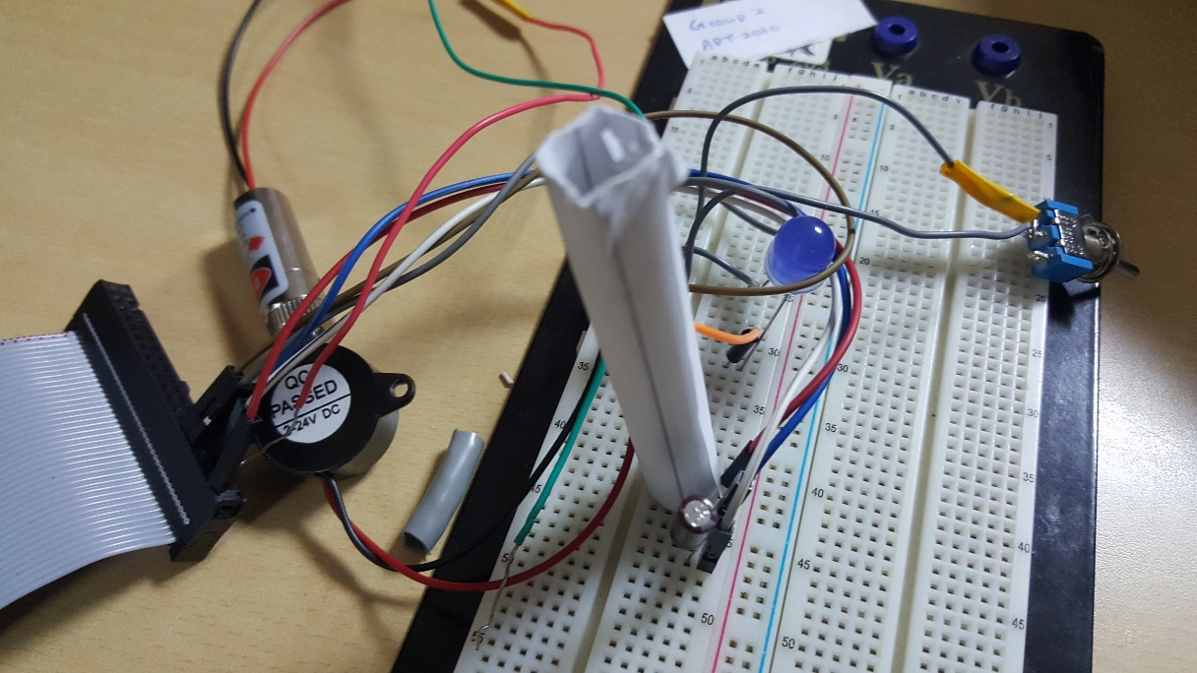

Figure 1: Shielding the LDR

The next step is to set up a resistor-capacitor circuit (RC circuit) using the 10µF capacitor and an LDR. The two components will need to be in series with each other. One leg of the LDR will be attached to a 3.3V pin (labeled 3V3) of the Raspberry Pi. The negative leg of the capacitor will be attached to a ground pin (labeled GND). The positive leg of the capacitor will be connected to any of the standard GPIO pins on the Raspberry Pi. The Buzzer can be step up by simply connecting the positive leg of the buzzer to any GPIO pin on your Raspberry Pi, and the negative leg to a Ground pin. The positive leg is normally the longer of the two, and most buzzers are labelled to show which side is positive. A single-throw switch can be added to manually arm and disarm the device. One possible configuration of the circuit is shown in Figure 2 below.

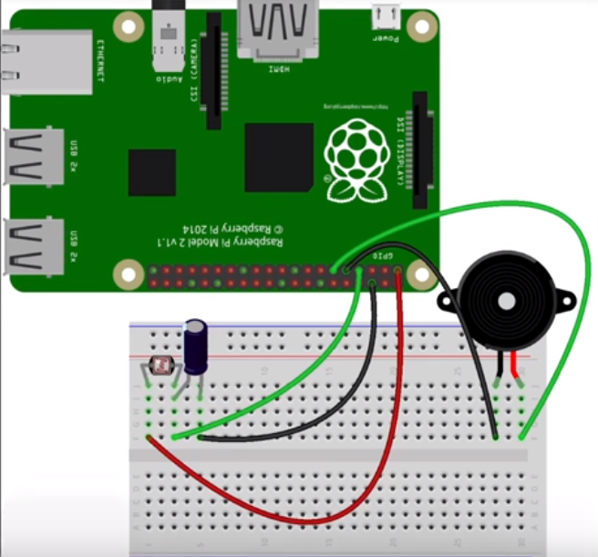

Figure 2: Circuit configuration

A simple circuit diagram for the circuit is shown below:

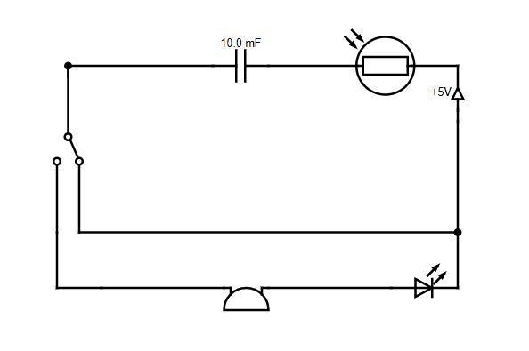

Figure 3 Circuit Diagram

The final step of the procedure is setting up the Raspberry pi and writing the code for the circuit to work. The Raspberry pi was booted up and the following code was written using the built in Python 3 IDE which came preinstalled with Raspbian:

#Importing libraries

from gpiozero import LightSensor, Buzzer

from time import sleep

Idr = LightSensor(14) #LDR connected to pin 14

buzzer = Buzzer(17) #Buzzer connected to pin 17

while True:

sleep(0.1)

if Idr.value <0.5:

buzzer.on()

sleep(0.2)

buzzer.off()

sleep(0.2)

buzzer.on()

else:

buzzer.off()

Once the code is run and the laser pointer is focused on the LDR, the device is armed and ready to serve its purpose.

# OBSERVATION AND RESULTS

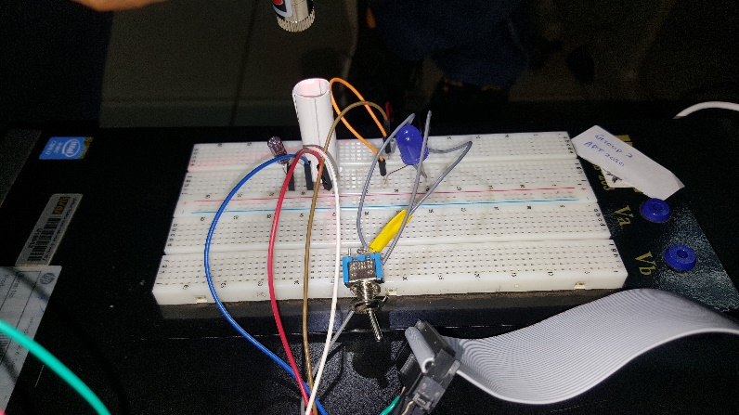

Figure 4: LASER focused at the LDR

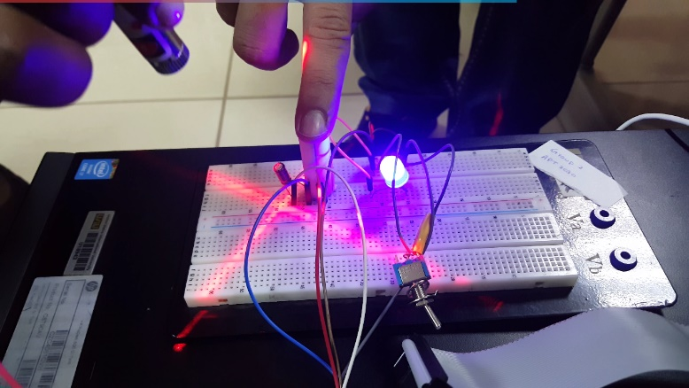

Figure 5: LASER intercepted

As seen in Figure 3 above, when the laser is pointed at the LDR, there is no output from the device.

When the laser beam is broken or intercepted by the finger, as seen in Figure 4, an alarm is triggered through the Buzzer and the LED starts flashing.

# 

# DISCUSSION OF RESULTS

The resistance of an LDR changes depending on the amount of light that is falling on it. The more the light that hits the LDR, the lower is its resistance. Therefore, when the laser is pointed at the LDR, the resistance is low and when the laser is intercepted by a person/object, the resistance is high.

The Raspberry Pi’s GPIO pins are only capable of being on or off, and in turn detecting whether another device is on or off. To use analogue components, for example LDRs, a little more work needs to be done and this is where the Capacitor plays its role.

The rate at which the capacitor charges is constant as long as the resistance is constant. Using a resistor with a larger resistance will case the charging process to slow down. Using a smaller resistance will make charging faster.

If the time taken for the capacitor to charge can be measured, we can fairly accurately calculate the resistance of the resistor. This means that you could use this type of circuit to measure the resistance of a component such as a light-dependent resistor.

Once the program detects the Resistance, it compares the value to a preset resistance value and if the value read by the LDR is lower than the preset value, the program sounds the Buzzer and flashes the LED making it known that the laser beam has been intercepted by an intruder.

# CONCLUSION

The laser trip wire goes off that is; the LED lights and the Buzzer begins to sound when the LDR no longer receives light from the laser. When a person or object interferes with the light directed to the laser.

This is because the LDR is dependent on light therefore with the way the connection of the laser trip wire is designed (the buzzer and LED are connected with the LDR), such that an interference with the source of light being sent or directed to the LDR, the laser beam. It will trigger an alarm (buzzing sounds from the Buzzer, light from the LED).

This therefore fulfills the purpose of our circuit as it can be applied in many places like homes, banks, administrative locations to be used as security reinforcement that will immediately alert people when an intrusion has been made.

# REFERENCES

A Raspberry Pi laser tripwire. (n.d.). Retrieved from https://projects.raspberrypi.org/en/projects/laser-tripwire

Matt. (2012, August 13). Reading Analogue Sensors with One GPIO Pin. Retrieved from

https://www.raspberrypi-spy.co.uk/2012/08/reading-analogue-sensors-with-one-gpio-pin/

Scott, M. [Marc Scott]. (2016, February 14). A Raspberry Pi Laser-tripwire [Video file]. Retrieved from https://www.youtube.com/watch?v=4oJiXlPs46o